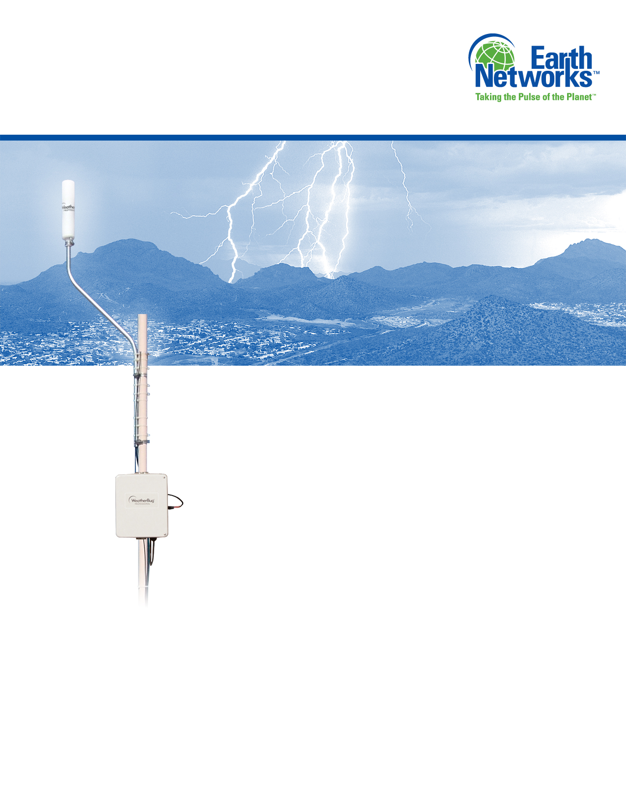

January 2015

***This document contains proprietary and confidential material owned by Earth Networks. Any unauthorized reproduction, use, or disclosure* *of this material, or any part thereof, is strictly prohibited.***

**Earth Networks PulseRad**

**Data Feed Version 0.1**

**Interface Control Document**

Table of Contents

1. Overview 3

2. PulseRad Data feed Connection Instruction 3

3. netCDF File Format 5

# Overview

Earth Networks specializes in deploying and operating large-scale networks of weather detection equipment and delivering derived content to end users through innovative applications and interfaces. Over the last 20 years, Earth Networks has deployed and operates the world’s largest commercial network of weather stations with approximately 8,000 units worldwide.

In 2009, the ENTLN was launched and has since grown into the world’s largest lightning network with more than 700 sensors. With the lightning network, Earth Network is able to generate PulseRad based on our ENTLN solution.

# PulseRad Data feed Connection Instruction

PulseRad utilizes a subscription key. End user making the PulseRad API Call will receive a response with a signed URL where the netCdf file is accessed.

All Pulse API calls require a subscription key appended to each call.

To access PulseRad API call:

https://earthnetworks.azure-api.net/pulserad/NetCdf/GetLatest?subscription-key**=<Your subscription key>**

When the PulseRad API is called, the returning JSON data is defined as below:

|  |
| --- |
| {  "Result": [  {  "Region": "BR",  "SignedUrl": "https://[some URL endpoint]",  "LastModifiedDate": "2015-01-14T13:20:26-05:00"  },  {  "Region": "EU",  "SignedUrl": "[some URL endpoint]",  "LastModifiedDate": "2015-01-14T13:20:26-05:00"  }  ],  "Code": 200,  "ErrorMessage": null,  "Id": "c39dbae4-d57a-4986-9e9a-529647a43eab"  } |

The following describes the attributes from the PulseRad API returning data object:

|  |  |
| --- | --- |
| Attribute Name | Description |
| Result | A JSON list containing all the region netCDF that are defined and assessable by the user |
| Code | The return code of the API call. In most cases, 200 should be returned. |
| ErrorMessage | If there is a problem with the API call, the ErrorMessage will describe the problem. |
| Id | Unique identifier for each web api call |
| Region | The region of the pulse rad netCDF that is generated |
| SignedUrl | The signed URL provides direct access to the netCdf files |
| LastModifiedDate | The timestamp when the data file is generated |

# netCDF File Format

The signedUrl will direct the user to retrieve the netCDF file. For more information about the netCDF file structure, specification and prasing, please refer to the following site for details: http://www.unidata.ucar.edu/software/netcdf/

When the netCDF is parsed correctly, the following dimensions are defined:

|  |  |
| --- | --- |
| Dimension name | Description |
| Lat | The number of latitude points defined in the netCDF file |
| Lon | The number of longitude points defined in the netCDF file |

The following defines the variables in the netCDF file:

|  |  |
| --- | --- |
| Variable name | Description |
| Float lat(lat) | The list containing all the latitude points |
| Float lon(lon) | The list containing all the longitude points |
| Float dbz (lat, lon) | The list containing all the dbz values based on [latitude, longitude] |
| Float echoTop(lat, lon) | The list containing all the echoTop values based on [latitude, longitude] |
| Float vil (lat, lon) | The list containing all the vil values based on [latitude, longitude] |

The following defines the global attributes in the netCDF file:

|  |  |
| --- | --- |
| Global attribute name | Description |
| Source | The source of the data |
| Version | The data source version |
| Projection | The projection used to generate the netCDF file. WGS84 is the projection Earth Networks supports currently. |
| datetime | The time when the file is generated |

A typical netCDF file in its CDL representation will therefore look like the following:

|  |
| --- |
| netcdf CA_2014-11-24T00-00Z {  dimensions:  lat = 2082 ;  lon = 12743 ;  variables:  float lat(lat) ;  float lon(lon) ;  float dbz(lat, lon) ;  dbz:units = "decibels relative to Z" ;  float echoTop(lat, lon) ;  echoTop:units = "meters" ;  float vil(lat, lon) ;  vil:units = "kilograms per meter cubed" ;  // global attributes:  :source = "Earth Networks, Inc." ;  :version = 1. ;  :projection = "WGS84" ;  :datetime = "2014-11-24T00:00Z" ;  data:  lat = [some data, coma separated];  lon = [some data, coma separated];  dbz = [some data, coma separated];  echoTop = [some data, coma separated];  vil = [some data, coma separated];  } |